Press Release
Softing Industrial
New Managing Director at Softing Industrial Automation
Haar, November 20, 2019 – As of November 1st, 2019, Frank Steinhoff took over the position of Managing Director at Softing Industrial Automation GmbH.
Effective November 1st, 2019, Frank Steinhoff is the new Managing Director of Softing Industrial Automation GmbH. He is based at the company's headquarters in Haar near Munich. Frank Steinhoff has many years of experience in medium-sized and corporate-oriented companies. He was a member of the management board at Endress+Hauser (E+H), where he was responsible for worldwide research and development and industrial engineering at E+H Flowtec AG. On behalf of the Endress family, he founded the corporate start-up TrueDyneSensors AG for E+H, which addresses the technology of silicon-based microsensors. Most recently, he held the position of COO & CTO of Knoll Firmengruppe GmbH.
“We are pleased to have found in Frank Steinhoff an experienced automation expert for the position of Managing Director. Mr. Steinhoff has extensive experience in professional project management and in the expansion of promising business areas, including the digitalization of process and factory automation. He has an excellent network in the industry and will continue to successfully advance Softing Industrial's strategies,” says Dr. Wolfgang Trier, member of the Executive Board of Softing AG.
“I am very much looking forward to this new task and to working with a committed and experienced team,” says Steinhoff. Softing has a broad portfolio of software and hardware products for technology and data integration in a variety of factory and process automation industries. Overall, Frank Steinhoff believes that the company is very well positioned to implement the digital transformation, which affects both large and medium-sized companies. “As a specialist for networked digital communication, Softing is ideally positioned to act as a “digital bridge builder” between automation / OT / IoT and classical IT. We have a broad base and are therefore in a good starting position to support our customers in their digital transformation in a competent and experienced manner. There is currently a large market potential worldwide for the expansion of digital industrial networking. When it comes to practical implementation, it is important to take account of specific operational conditions and the direct benefits to the customer. Softing has, so to speak, the “digital lubricants” for networked automation and can support technology upgrade projects. As a system and solution partner to both company OT and IT, Softing offers secure solutions for integrating automation with cloud and IoT platforms. As a medium-sized company, we are at equal terms with many of our customers and speak their language. The customer with his specific needs comes first. Therefore, it is important for us to maintain a high-quality, long-term customer relationship, even after the successful implementation of our products. I look forward to working with the Softing Industrial team to further shape and significantly expand this in the long run.”
##
Word count: 474
No. of characters: 3.118
Image Download:
PM_Softing_neuer_GF_72dpi_rgb
PM_Softing_neuer_GF_300dpi_cmyk
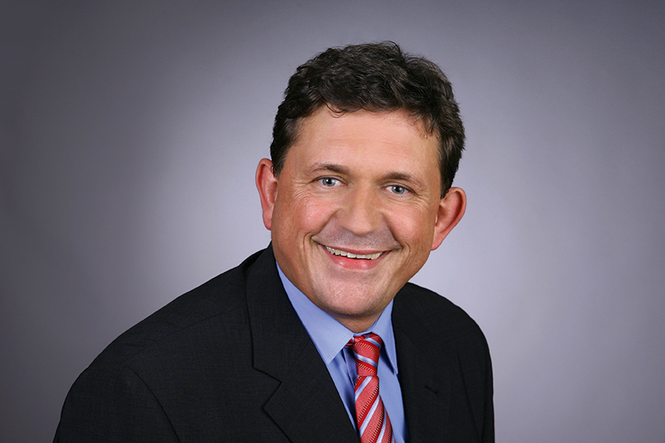 Caption: As per November 1st, 2019, Frank Steinhoff is the new Managing Director of Softing Industrial Automation in Germany.
About Softing Industrial
Softing connects disparate automation components to feed data from the shop floor to the cloud for control and analytics. The company’s products enable the monitoring and diagnosis of communication networks and thus ensure a reliable data flow. In this way, they create the basis for the optimization of production processes. For more information: https://industrial.softing.com/en

Press Contact:
Stephanie Widder
Marketing Communications Specialist
Industrial – Data Networks
Softing Industrial Automation GmbH
Richard-Reitzner-Allee 6
D-85540 Haar
Phone: +49-(0)89-45656-365
Email: stephanie.widder@softing.com

