Press Release
Softing Industrial
Softing Industrial Data Networks Presents Connectivity Solutions for the Process Industry
Haar, September 30, 2019 – Softing Industrial Data Networks will show smart gateways for multi-protocol process control and a mobile plug & play solution for configuration and maintenance of field devices at the trade show SPS smart production solutions from November 26 to 28, 2019, in Nuremberg, in Hall 5, Booth 346.
With smart gateways and mobile enterprise solutions, Softing Industrial Data Networks presents itself at the SPS 2019 trade show in Nuremberg as a partner for the process industry on its way to digitalization.
Gateways for multi-protocol process control
In many process plants control systems of different manufacturers and different generations are in operation due to long running times. The resulting different communication interfaces make it difficult to exchange production and plant data across systems when implementing industry 4.0 applications. Softing's smartGate product family supports users in integrating disparate protocols, ensures end-to-end digital data exchange and thus creates the prerequisites for greater efficiency and flexibility in production.
In addition to the pnGates for PROFINET and the mbGates for Modbus/TCP, Softing will present the new Ethernet/IP to PROFIBUS gateways epGate DP, epGate PA and epGate PB at the fair. This completes the smartGate product family which now supports all Ethernet protocols relevant to the process industry: PROFINET, Ethernet/IP and Modbus/TCP. The epGates enable the convenient connection of PROFIBUS devices to Ethernet/IP controllers, e.g. from Rockwell, Schneider Electric or Emerson.
There is also news for the Modbus/TCP to PROFIBUS gateways. At the fair, version 1.20 of mbGate DP, mbGate PA and mbGate PB will be on display, which has been extended by the "High Availibility" option. It allows the operation of a redundant system with two Modbus/TCP controllers and two Modbus/TCP gateways. In this way, system availability is ensured even in the event of a connection failure. The mbGates enable the direct integration of PROFIBUS PA and DP segments into Modbus/TCP systems. They act as Modbus server and PROFIBUS master and connect up to four PROFIBUS PA segments as well as one DP segment with Modbus TCP.
All gateways allow use of the existing power supply in technology upgrade projects, which significantly reduces engineering costs. Configuration and asset management can be carried out using industry-standard tools.
Mobile Enterprise Solutions
Modern process plants require digital, mobile, networked and standardized solutions that make data from plants, machines and field devices easily accessible and streamline maintenance procedures for configuring, commissioning and troubleshooting the devices. This is where Softing's mobile interface mobiLink comes in. It provides access to the three most important communication protocols in process automation – HART, FOUNDATION Fieldbus and Profibus PA – via a single interface. The connection to the mobile device can be made via USB or Bluetooth. With the newly available FDI Communication Server it is now possible to use mobiLink with FDI applications. The DevCom app for Android or Windows adds an application for device parameterization to the offering. A new version – mobiLink Power – will be available at the beginning of 2020. This will allow field devices to be supplied with power, which is obtained via the USB port. An external power supply for the field devices is no longer necessary.
Softing Industrial Data Networks will be exhibiting at SPS 2019 together with its Data Intelligence division in Hall 5, Booth 346.
##
Word count: approx. 551
No. of characters: approx. 3,665
Image 1: Smart Industry
Download Image 1: Smart Industry 300 dpi
Download Image 1: Smart Industry 72 dpi
Image 2: epGate (PA/DP/PB)
Download Image 2: epGate (PA/DP/PB) 300 dpi
Download Image 2: epGate (PA/DP/PB) 72 dpi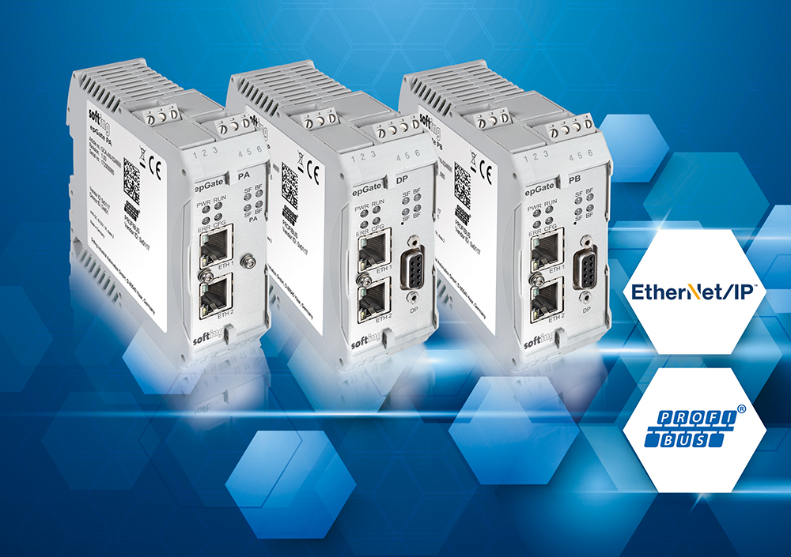
Image 3: mbGate (PA/DP/PB)
Download Bild 3: mbGate (PA/DP/PB) 300 dpi
Download Bild 3: mbGate (PA/DP/PB) 72 dpi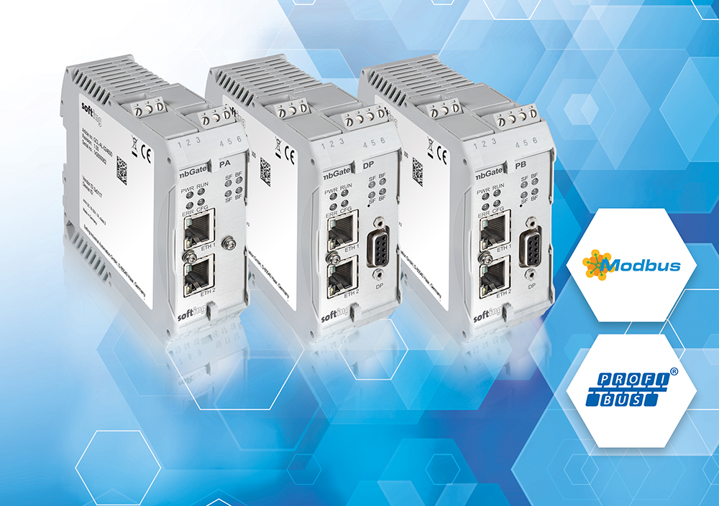
Image 4: mobiLink
Download Image 4: mobiLink 300 dpi
Download Image 4: mobiLink 72 dpi 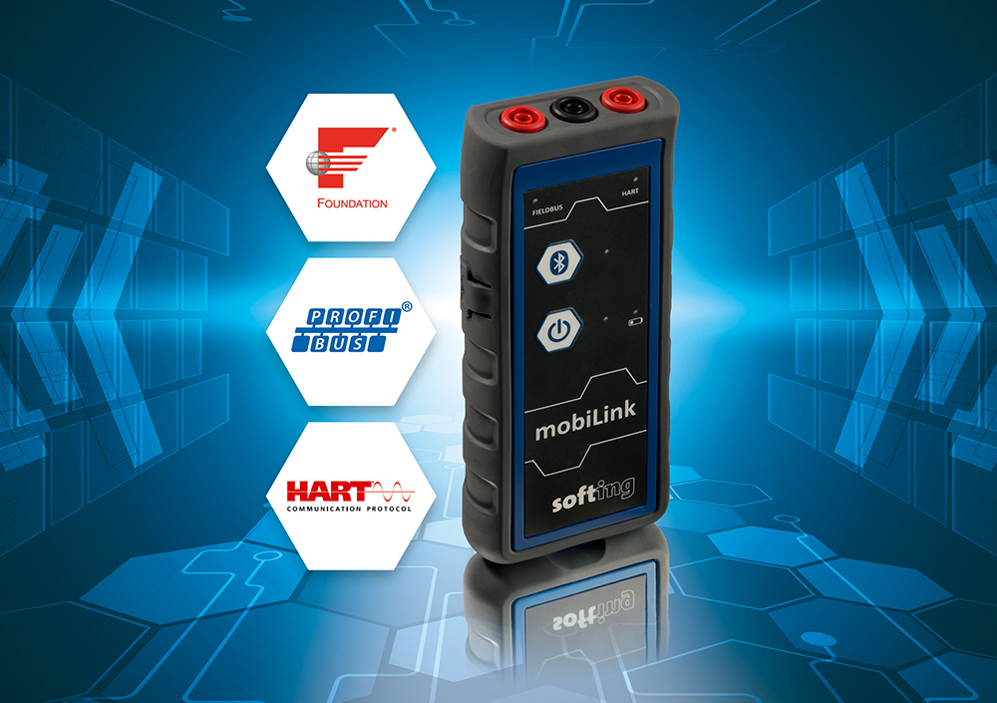
About Softing Industrial
Softing connects disparate automation components to feed data from the shop floor to the cloud for control and analytics. The company’s products enable the monitoring and diagnosis of communication networks and thus ensure a reliable data flow. In this way, they create the basis for the optimization of production processes. For more information: https://industrial.softing.com/en

Press Contact:
Stephanie Widder
Marketing Communications Specialst
Industrial – Data Networks
Softing Industrial Automation GmbH
Richard-Reitzner-Allee 6
85540 Haar
Phone: +49-(0)89-45656-365
Email: stephanie.widder@softing.com

