Press Release
Softing Industrial
Mobile Solution for Configuration and Parameterization of Field Devices in the Process Industry
Haar, October 17, 2019 – Endress+Hauser is now offering its Field Xpert together with Softing's mobiLink interface as a practical bundle for parameterizing and commissioning field devices.
The combination of Softing's mobiLink interface with the Field Xpert SMT70 or SMT77 Tablet PC from Endress+Hauser offers users a simple and safe system solution for configuring and parameterizing field devices for the most important process automation protocols - HART, PROFIBUS PA and FOUNDATION Fieldbus. The bundle includes a Field Xpert SMT70 or SMT77 tablet with pre-installed CommDTMs (HART, PROFIBUS PA and FOUNDATION Fieldbus), a mobiLink interface that establishes the connection to the tablet via Bluetooth, and optionally a license to use mobiLink for the configuration of FOUNDATION Fieldbus and PROFIBUS PA field devices. mobiLink is now available from Endress+Hauser under the name FieldPort SFP50.
Dr. Rolf Birkhofer, CEO of Endress+Hauser Digital Solutions: “mobiLink is seamlessly integrated into our Field Xpert, which can be used as a powerful Tablet PC for device configuration in Zone 2, Zone 1 or in non-explosive areas. It provides easy access to all field instruments and is a simple, touchable tool that allows field instruments to be managed throughout their lifecycle.”
Peter Juengling, Key Account Manager at Softing Industrial: “We are proud to be able to look back on a long-standing partnership with Endress+Hauser. We already offer a range of interface products that connect to the Field Xpert SMT70 or SMT77 tablet for device configuration and to Endress+Hauser's FieldCare SFE500 Plant Asset Management Software. With mobiLink we simplify mobile access to field devices for plant operators, system integrators, device developers and other users in the process industry. Together with the Ex-certified tablets from Endress+Hauser, we now have a cost-effective and easy-to-use all-in-one solution.
More information about connectivity solutions with Endress+Hauser can be found on the Softing Website: https://industrial.softing.com/en/solutions/endress-hauser-connectivity-solutions.html
##
Word count: 312
No. of characters: 2,200
Download Press Image:
PM_mobiLink_E_H_102019_72dpi_rgb
PM_mobiLink_E_H_102019_300dpi_cmyk
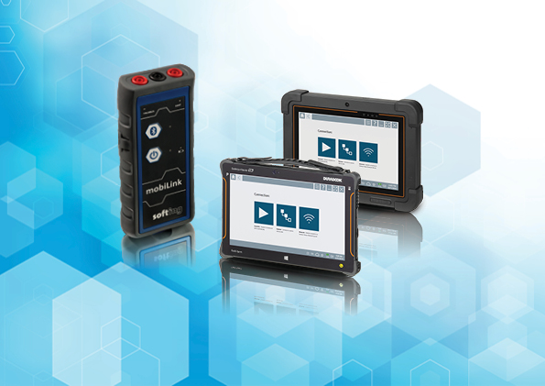
Caption: The combination of Softing's mobiLink interface with the Field Xpert SMT70 or SMT77 Tablet PC from Endress+Hauser offers users a simple and safe system solution for configuring and parameterizing field devices.
About Softing Industrial
Softing connects disparate automation components to feed data from the shop floor to the cloud for control and analytics. The company’s products enable the monitoring and diagnosis of communication networks and thus ensure a reliable data flow. In this way, they create the basis for the optimization of production processes. For more information: https://industrial.softing.com/en

Press Contact:
Stephanie Widder
Marketing Communications Specialst
Industrial – Data Networks
Softing Industrial Automation GmbH
Richard-Reitzner-Allee 6
85540 Haar
Phone: +49-(0)89-45656-365
Email: stephanie.widder@softing.com

