Press Release
Softing Industrial
High plant availability and simplified PROFIBUS integration for process control
Haar, May 14, 2019 – Softing Industrial just released version 1.20 of its Modbus to PROFIBUS gateways adding redundancy for critical process control applications and adding XML import for simplified integration into Schneider Electric engineering systems.
Softing's Modbus to PROFIBUS Gateways mbGate PA, mbGate PB and mbGate DP enable the direct integration of PROFIBUS PA and DP segments into Modbus/TCP systems. They act as Modbus server and PROFIBUS master and connect up to 4 PROFIBUS PA segments as well as 1 DP segment with Modbus TCP. Version 1.20 now supports the operation of two redundant gateways in combination with two redundant Modbus controllers. In this way, system availability is ensured even in the event of a connection failure. Furthermore, the PROFIBUS configuration from the gateway can now be easily transferred to Schneider's Unity PRO via XML import. Initial engineering is thus reduced to a minimum and changes in the system configuration can be transferred quickly to the control system eliminating risk of error.
mbGate PA, PB and DP are part of Softing's gateway family for multi-protocol process control which includes gateways with server functionality for Modbus TCP, PROFINET and Ethernet/IP. The gateways enable fast and easy field device connection for integrated, digital communication in process plants. In this way, users modernize and expand their existing installations quickly and cost-effectively and create the basis for more efficiency and flexibility in their production. More information is available on the Softing Website: https://industrial.softing.com/en/products/gateways/gateways-for-multi-protocol-process-control.html
##
Word count: approx. 249
No. of characters: approx. 1,750
Download Press Image 300dpi
Download Press Image 72dpi
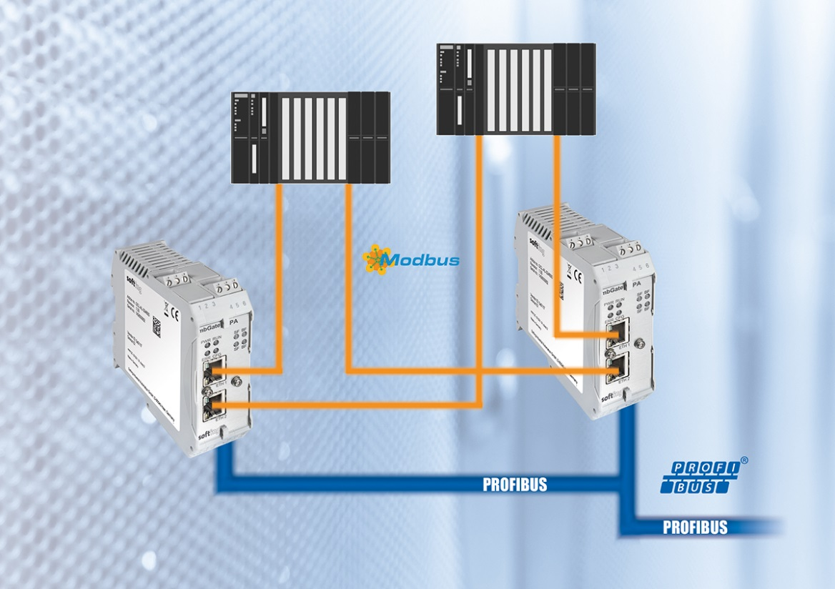
About Softing Industrial
Softing Industrial specializes in the implementation of digital data exchange and the improvement of data communication in industrial automation applications. Its portfolio includes hardware and software products and customized solutions for seamless communication at OT level (field level/operating technologies) and easy data exchange with the IT level (information technologies). The products and solutions from Softing Industrial are designed to meet the increasing requirements of integrated and secure data communication. They offer superior functionality, are easy to use and enable customers to optimize industrial value creation processes and improve the efficiency of machinery and equipment. Further information is available at https://industrial.softing.com/en

Press Contact:
Stephanie Widder
Marketing Communications Specialist
Industrial – Data Networks
Softing Industrial Automation GmbH
Richard-Reitzner-Allee 6
85540 Haar
Phone: +49-(0)89-45656-365
Email: stephanie.widder@softing.com

