Press Release
Softing Industrial
dataFEED OPC Suite Extended from Softing Industrial now supports the integration of production data from XML files
Haar, February 02, 2023 – The new "File Read" function of dataFEED OPC Suite Extended V5.25 enables access to process data available via XML files.
dataFEED OPC Suite Extended is an all-in-one solution for OPC communication and cloud connectivity, providing access to controllers and IoT devices of leading manufacturers. With the new File Read functionality, the suite ensures access to brownfield PLCs, devices and machines that deliver data via XML files.
Fast and easy data integration
File Read allows process values from XML files to be integrated quickly and securely into production control applications such as MES or OEE via the standard OPC Classic or OPC UA interfaces. The production data can also be integrated into IIoT cloud solutions via MQTT or REST. Furthermore, there is the option of data logging for documentation, analysis, or verification in a separate database.
An all-in-one data integration solution
The dataFEED OPC Suite enables access to the controllers of leading manufacturers such as Siemens SIMATIC S7, Rockwell ControlLogix, B&R, Mitsubishi as well as Modbus controllers (e.g., from Wago). It acts as a gateway between the two OPC standards so that existing OPC Classic components and applications can be integrated into modern OPC UA solutions for Industry 4.0 applications. Production data is transferred to IoT Cloud or Big Data applications via the MQTT and REST protocols. The suite supports the storage of production data in a file, in an SQL database, or in MongoDB and CouchDB. Thanks to the extensive data pre-processing functionality, data can be easily and flexibly customized. With OPC UA Reverse Connect functionality, the suite also ensures secure communication between OPC UA components separated by firewalls or DMZs.
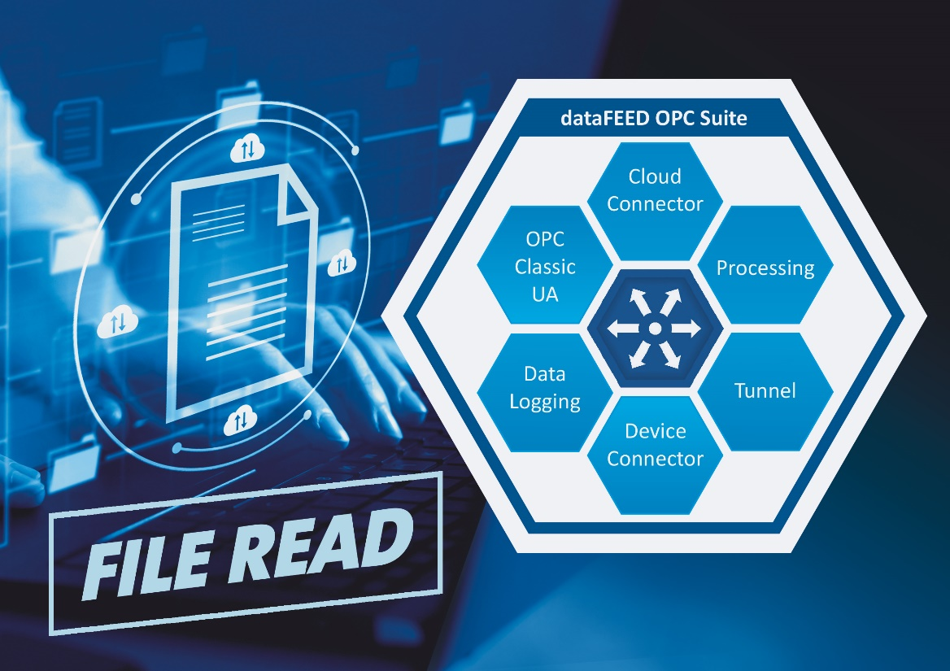
Caption: File Read provides access to process data available via XML files.
(Source: Softing Industrial)
##
No. of characters/words: ca. 1,880/290
About Softing Industrial
Softing connects disparate automation components to feed data from the shop floor to the cloud for control and analytics. The company's products enable communication networks to be monitored and diagnosed to ensure a reliable flow of data, thereby creating the basis for optimizing production processes. For more information, please visit https://industrial.softing.com

Press Contact:
Stephanie Widder
Marketing Communications Specialist
Softing Industrial Automation GmbH
Richard-Reitzner-Allee 6
85540 Haar
Phone: +49-(0)89-45656-365
Email: stephanie.widder@softing.com

