Press Release
Softing Industrial
New Management at Softing Industrial Automation GmbH
Haar, February 10, 2022 – Softing Industrial Automation GmbH based in Haar near Munich today announced that Thomas Hilz and Thomas Rummel jointly took over as the company’s managing directors effective January 10, 2022.
Thomas Hilz is in charge of Marketing and Sales while also taking on the role of executive management spokesman. He is also responsible for managing Softing Industrial’s Nuremberg office. Thomas Rummel is in charge of Development and Product Management, and Softing's R&D site in Cluj/Romania. The previous managing director, Frank Steinhoff, left the company on December 31, 2021.
Thomas Rummel and Thomas Hilz both contribute many years of experience with the company to their new roles. Thomas Hilz joined Softing in 2010, working first as Product Manager before taking over as Market Segment Manager for the Process Automation division. After spending two and a half years as Business Development Manager at networking specialist Moxa, he returned to Softing at the end of 2017, where he was responsible for Product Marketing and Strategic Account Management. Thomas Rummel joined Softing in 1997 in Software Development, a department whose head he become in 2008. In 2018, he became Senior Vice President in charge of Development and Product Management, for which he will continue to be responsible in his new role as managing director.
Executive Board Chairman Dr. Wolfgang Trier sees the new dual leadership set-up as a positive step for Softing: “Thomas Hilz and Thomas Rummel are two long-standing and experienced employees who have made important contributions to the development of the company. I am certain that, as a team, they will continue expanding Softing's solid business base and successfully master upcoming market challenges.”
In his new position as Managing Director, Thomas Hilz intends to build on the close relationship to partners and customers he has established over the years: “We want to support our customers as a competent partner and specialist for industrial communication, with the specific needs of our customers being our top priority. We offer a broad range of solutions for OT/IT integration, asset management and technology integration, supporting users in both factory and process automation in their digital transformation efforts. I look forward to further expanding this offering together with our dedicated team at Softing.”
Thomas Rummel believes that his many years of experience in software development and product management are an important asset in his new role: “Experts from Softing have been involved in the specification of standards for industrial communication from a very early stage. We are actively involved in major technology organizations, which enables us to be at the forefront of the latest technological developments. I am delighted to be working with a team of experienced specialists with whom we can successfully shape the dynamic development of the IIoT and cloud solution domains in particular.”
##
No. of characters / words: approx. 3,040
Image:
Download CMYK
Download RGB
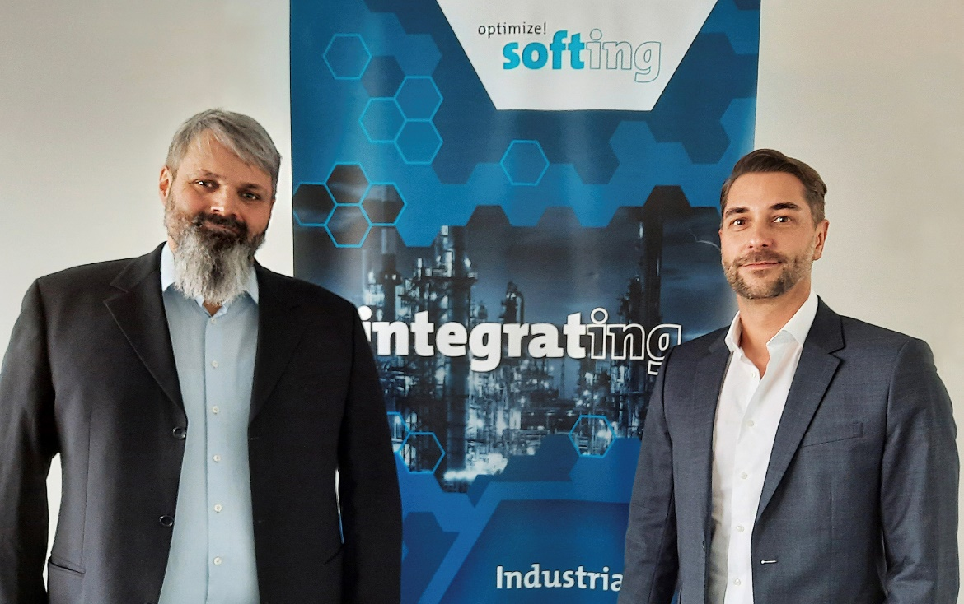Caption: Thomas Rummel (left) and Thomas Hilz (right) are the new managing directors of Softing Industrial Automation GmbH
(Source: Softing Industrial)
About Softing Industrial
Softing Industrial connects disparate automation components to feed data from the shop floor to the cloud for control and analytics. The company's products enable communications networks to be monitored and diagnosed to ensure a reliable flow of data, thereby creating the basis for optimizing production processes. For more information, please visit https://industrial.softing.com

Press Contact:
Stephanie Widder
Marketing Communications Specialist
Softing Industrial Automation GmbH
Richard-Reitzner-Allee 6
85540 Haar
Phone: +49-(0)89-45656-365
Email: stephanie.widder@softing.com

