Press Release
Softing Industrial Automation

Softing Industrial Automation partners with Portainer.io for efficient and scalable management of machine connectivity for IIoT Solutions
Haar, December 15, 2022 – Softing Industrial Automation becomes a value-added reseller of Portainer, a platform for managing containerized software applications. The combination of the Softing connectivity products with the Portainer.io offering makes it easier for users to operate and manage their IIoT solution.
Portainer is a platform for the efficient management of containerized software applications. Portainer simplifies usability, even for non-IT experts, to efficiently manage Docker and Kubernetes environments, for example.
The combination of the containerized connectivity products from Softing with the Portainer platform allows users to efficiently deploy machine connectivity at the interface of OT and IT as part of an "Industrial Edge" without requiring deep IT expertise. Applications that use machine data can be operated on-prem, cloud-based, or in hybrid scenarios. Customers benefit from the openness and modularity of a solution architecture that leverages IT standards and from the ease of scaling their IIoT solution across multiple sites.
The Softing Industrial Automation connectivity offering includes software products that collect data from machines and devices in automation networks and make it available for IIoT applications. These include the products of the "edgeConnector family", “edgeAggregator” and "smartLink SW-HT". The products enable connectivity for control and CNC machines, for sensors and actuators, as well as data pre-processing, data normalization and data aggregation with advanced IT security.
"IIoT projects often require access to process and machine data, which is the basis for many project goals, such as OEE optimization," says Tobias Muehlnikel, CPO & CTO of Portainer's Edge Business Unit. " With Portainer, Softing's reliable and containerized connectors can be easily and securely managed and rolled out. This is an essential prerequisite for implementing IIoT projects quickly and successfully."
"IT is the driver of innovation in industrial production," adds Thomas Hilz, Managing Director of Softing Industrial Automation GmbH. "The cooperation with Portainer supports our claim to act as a bridge builder between IT and OT and to simplify the development of innovative IIoT solutions for our customers."
##
No. of characters / words: approx. 2,400 / 340
Image:
Download 300 dpi
Download 72 dpi
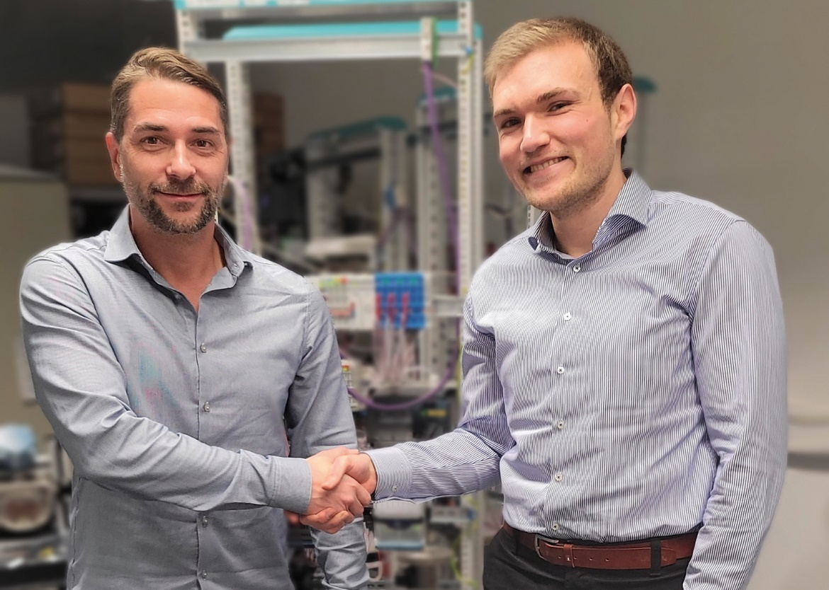
Caption: Thomas Hilz (left), Managing Director, Softing Industrial Automation GmbH, Tobias Muehlnikel (right), CTO and CPO Edge Business Unit at Portainer.io
Source: Softing Industrial Automation

About Softing Industrial Automation
Softing Industrial Automation connects disparate automation components to feed data from the shop floor to the cloud for control and analytics. The company's products enable communications networks to be monitored and diagnosed to ensure a reliable flow of data, thereby creating the basis for optimizing production processes. For more information, visit https://industrial.softing.com

About Portainer.io
Portainer.io is the independent software provider behind Portainer, the most widely used container management platform with over 3.4 billion downloads and over 600,000 active users.
Portainer enables containerized applications to be easily and securely managed on industrial controllers and PCs. In addition, specific functionalities are provided to enable efficient device management for IIoT projects.
For more information, visit https://www.portainer.io/edge-iiot-iot-device-management

Press Contact Softing Industrial Automation:
Stephanie Widder
Marketing Communications Specialist
Softing Industrial Automation GmbH
Richard-Reitzner-Allee 6
85540 Haar
Phone: +49-(0)89-45656-365
Email: stephanie.widder@softing.com

Press Contact Portainer.io
Diane Hannay
Digital Marketing and Community Manager
Portainer.io Limited
Email: diane.hannay@portainer.io

