Press Release
Softing Industrial

Softing provides a solution for integrating FANUC CNC data into Siemens Industrial Edge
Haar, October 10, 2022 – Softing expands its edgePlug family with edgePlug FANUC CNC. The Linux-based Docker container provides control data for use in Siemens Industrial Edge applications.
The Docker-based software products of Softing's edgePlug family connect controllers to applications in the Siemens Industrial Edge, an open, directly deployable edge computing platform. The new edgePlug FANUC CNC can be used to read machine and manufacturing data from FANUC CNC product series. Since May 2022 edgePlug SINUMERIK CNC is already available for accessing data from Siemens 840D CNC controllers. In a later step, access to SIMATIC S7 data will also be possible.
The edgePlugs are available in the Siemens Industrial Edge Marketplace and can be configured via the integrated Siemens Industrial Information Hub (IIH) tool. The purchase and licensing of the edgePlugs are fully integrated into the Siemens Industrial Edge Market Place. The licensing model is scalable and based on the number of control connections required.
The edgePlugs can be used for all edge, cloud, and on-premise applications that require access to control or machine data. The applications use the OPC UA servers or MQTT brokers available in the Siemens Industrial Edge to access the data provided. The edgePlugs in turn use Ethernet to connect to the controllers.
At sps 2022 in Nuremberg, Softing will present the edgePlugs in hall 5, booth 258.
##
No. of characters/words: approx. 1,500 / 234
Image:
Download CMYK
Download RGB
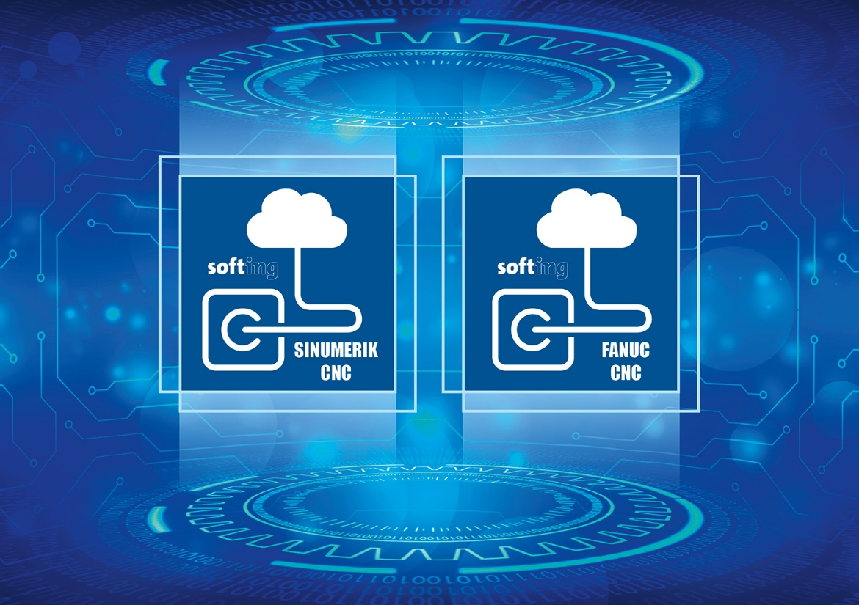
Caption: edgePlug Docker Containers from Softing Industrial provide connectivity for the Siemens Industrial Edge
(Source: Softing Industrial)
About Softing Industrial
Softing connects disparate automation components to feed data from the shop floor to the cloud for control and analytics. The company's products enable communications networks to be monitored and diagnosed to ensure a reliable flow of data, thereby creating the basis for optimizing production processes. For more information, please visit https://industrial.softing.com
Press Contact:
Stephanie Widder
Marketing Communications Specialist
Softing Industrial Automation GmbH
Richard-Reitzner-Allee 6
85540 Haar
Phone: +49-(0)89-45656-365
Email: stephanie.widder@softing.com

