Press Release
Softing Industrial

edgePlug Docker Containers from Softing Industrial Provide Connectivity for the Siemens Industrial Edge
Haar, May 12, 2022 – The first connectivity products of the edgePlug product family from Softing Industrial Automation GmbH are available on the Siemens Industrial Edge Marketplace.
Softing is launching its edgePlug product line for the Siemens Industrial Edge Ecosystem. The edgePlugs are Linux-based Docker containers that provide access to FANUC and Sinumerik 840D CNC data and deliver it seamlessly into the Siemens Industrial Edge. In a later step, access to SIMATIC S7 data will also be possible. This makes Softing the first 3rd party connectivity provider for users of the Siemens Industrial Edge. All edgePlug products can be configured via the integrated Siemens Industrial Information Hub (IIH) tool. The purchase and licensing of the edgePlugs are fully integrated into the Siemens Industrial Edge Market Place. The licensing model is scalable and based on the number of control connections required.
From mid-May, edgePlug SINUMERIK CNC will be available. It enables access to data from Siemens 840D CNC controllers.
edgePlug FANUC CNC will be available from July. It can be used to read machine and manufacturing data from FANUC CNC product series 30i-B, 31i-B, 32i-B, 35i-B, and 0i-F.
The edgePlugs can be used for all edge, cloud, and on-premise applications that require access to control or machine data. The applications use the OPC UA servers or MQTT brokers available in the Siemens Industrial Edge to access the data provided. The edgePlugs in turn use Ethernet to connect to the controllers.
Softing will present the edgePlugs in a virtual Siemens TechMeetup, June 2nd, 1:30 pm, at Hannover Messe. Also on June 2nd, Softing experts will be available for a personal talk at the Siemens Ecosystem Booth, hall 9 / booth D49, between 9 am and 12 pm.
Softing at Hannover Messe, May 30 to June 2nd, 2022:
- Partner Stand of OPC Foundation, hall 8 / booth F07,
- Partner Stand of PROFIBUS & PROFINET International, hall 9 / booth D68,
- Siemens Ecosystem Booth, hall 9 / booth D49, June 2nd, 9 am to 12 pm
Product information can be found on the Softing Website.
##
No. of characters/words: approx. 2,175 / 350
Image:
Download CMYK
Download RGB
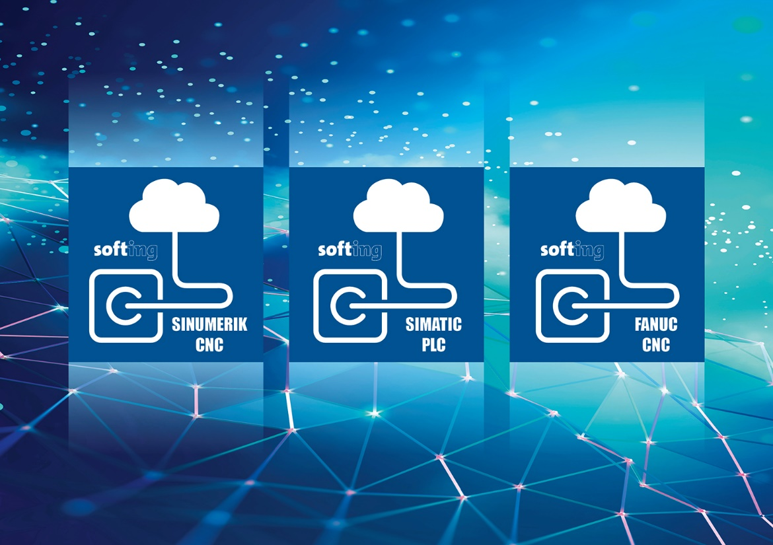Caption: edgePlug Docker Containers from Softing Industrial provide connectivity for the Siemens Industrial Edge
(Source: Softing Industrial)
About Softing Industrial
Softing connects disparate automation components to feed data from the shop floor to the cloud for control and analytics. The company's products enable communications networks to be monitored and diagnosed to ensure a reliable flow of data, thereby creating the basis for optimizing production processes. For more information, please visit https://industrial.softing.com
Press Contact:
Stephanie Widder
Marketing Communications Specialist
Softing Industrial Automation GmbH
Richard-Reitzner-Allee 6
85540 Haar
Phone: +49-(0)89-45656-365
Email: stephanie.widder@softing.com

