Press Release
Softing Industrial

edgeConnector Product Family from Softing Facilitates Integration into Configuration Platforms with New REST API
Haar, May 12, 2022 – The edgeConnector products from Softing's dataFEED family now include a REST API. This makes integration into configuration platforms even easier. In addition, a new licensing model offers more flexibility when deploying the individual products.
The new REST API in version 3.0 of Softing's edgeConnector products makes local or remote configuration much easier for users. The product family currently includes edgeConnector Siemens, edgeConnector 840D and edgeConnector Modbus. The software modules are based on Docker technology and provide state-of-the-art access to process data in SIMATIC S7, SINUMERIK 840D and Modbus TCP controllers. In the past, a separate login via the local configuration interface was necessary for each product. This is now done by the new edgeConfigurator, which allows all edgeConnectors to be accessed via the REST API. The edgeConfigurator is also based on Docker technology and is used in parallel with the edgeConnectors. The configurator can be deployed on-premise or additionally in the Microsoft Azure cloud, allowing REST API access from the cloud to the edgeConnectors' on-premise environment. Using the REST API, edgeConnectors can now be configured even more easily from a third-party application.
The new license model of version 3.0 distinguishes between Basic (edgeConnector Modbus), Advanced (edgeConnector Modbus and edgeConnector Siemens) and Premium (all edgeConnector products). The licenses no longer refer to data points, instead they only account for the connected controllers. The user can choose between license options of 1, 5, 10 and 20 connections. This saves him the time-consuming calculations of the required data points. In addition, a 1-year software upgrade is included in the license agreement. With the Softing Floating License Server, the licenses can be flexibly used for the Docker applications currently operated by the user.
All edgeConnector products are ready for use very quickly thanks to container technology. They are operated on standard hardware and can be easily administered centrally. The integrated MQTT Publisher/ Subscriber functionality allows for flexible setup of Industrial IoT solutions (IIoT). They support state-of-the-art security standards such as SSL/TLS, X.509 certificates, authentication, and data encryption. This gives users an easy and secure way to integrate data from production into innovative and flexible IIoT solutions. The individual edgeConnector products can be downloaded from Docker Hub or the Microsoft Azure Marketplace and tested for free. More information is available on the Softing website.
At the Hannover Messe (May 30 to June 02nd, 2022) Softing will present the edgeConnector products at the OPC Foundation booth, hall 8 / booth F07.
Softing at Hannover Messe, May 30 to June 2nd, 2022:
- Partner Stand of OPC Foundation, hall 8 / booth F07,
- Partner Stand of PROFIBUS & PROFINET International, hall 9 / booth D68,
- Siemens Ecosystem Booth, hall 9 / booth D49, June 2nd, 9 am to 12 pm
##
No. of characters / words: approx. 3,130 / 470

Image:
Download CMYK
Download RGB
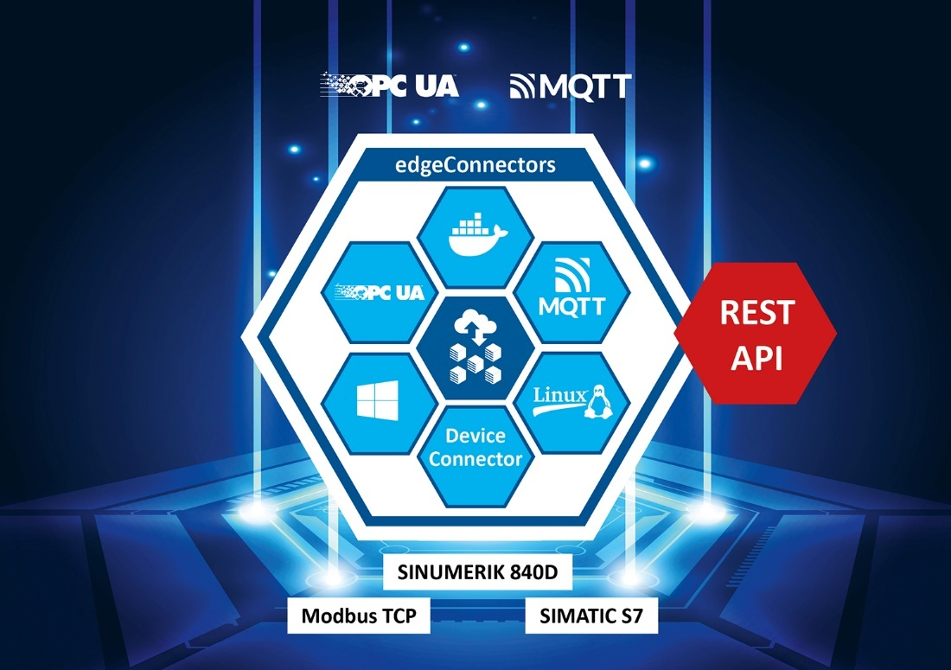Caption: Integration into configuration platforms become easier with new REST API (Source: Softing Industrial)
About Softing Industrial
Softing connects disparate automation components to feed data from the shop floor to the cloud for control and analytics. The company's products enable communications networks to be monitored and diagnosed to ensure a reliable flow of data, thereby creating the basis for optimizing production processes. For more information, please visit https://industrial.softing.com

Press Contact:
Stephanie Widder
Marketing Communications Specialist
Softing Industrial Automation GmbH
Richard-Reitzner-Allee 6
85540 Haar
Phone: +49-(0)89-45656-365
Email: stephanie.widder@softing.com

