Press Release
Softing Industrial

Softing Introduces a Hardware Module for Implementing Ethernet-APL Field Devices
Haar, May 12, 2022 – commModule APL, a new hardware module from Softing Industrial Automation, is designed to support device manufacturers in implementing Ethernet-APL field devices for the process industry quickly and reliably.
Ethernet Advanced Physical Layer (Ethernet-APL) is the new standard for end-to-end digital communication in the process industry and is also suitable for use in hazardous areas. Device manufacturers will have to prepare themselves for growing demand from end-users for this modern data transmission technology. They now face the challenge of developing and certifying new Ethernet-APL-capable devices within the shortest possible time-to-market - ideally without having to build up extensive specialist knowledge of Ethernet-APL. As a ready-to-use and pre-certified hardware for the implementation of Ethernet-APL field devices, commModule APL supports manufacturers in exactly this challenge.
The hardware module provides connectivity to Ethernet-APL as well as an application software that can be easily configured to implement the required behavior of the respective field device. commModule-APL is delivered with a pre-installed PROFINET stack. It provides a configurable application data model and commands mapping to migrate existing HART and Modbus devices to Ethernet-APL. This does not require writing a single line of code. The assignment to HART or Modbus commands is done with the accompanying commScripter tool. commModule APL has already passed comprehensive EMC (electromagnetic compatibility) and environmental testing, as well as conformance testing for the Ethernet-APL Physical Layer and for the PROFINET protocol with PA Profile 4.02. It is also pre-certified in accordance with ATEX and IECEx. These features drastically reduce the effort, risk and time required to develop device hardware.
More information is available on the Softing website.
At the Hannover Messe (May 30 to June 02, 22), Softing will present the commModule APL at the partner booth of PROFIBUS & PROFINET International, Hall 9 / Booth D68.
Softing at Hannover Messe, May 30 to June 2nd, 2022:
- Partner Stand of OPC Foundation, hall 8 / booth F07,
- Partner Stand of PROFIBUS & PROFINET International, hall 9 / booth D68,
- Siemens Ecosystem Booth, hall 9 / booth D49, June 2nd, 9 am to 12 pm
##
No. of characters / words: approx. 2,340 / 355
Image:
Download CMYK
Download RGB
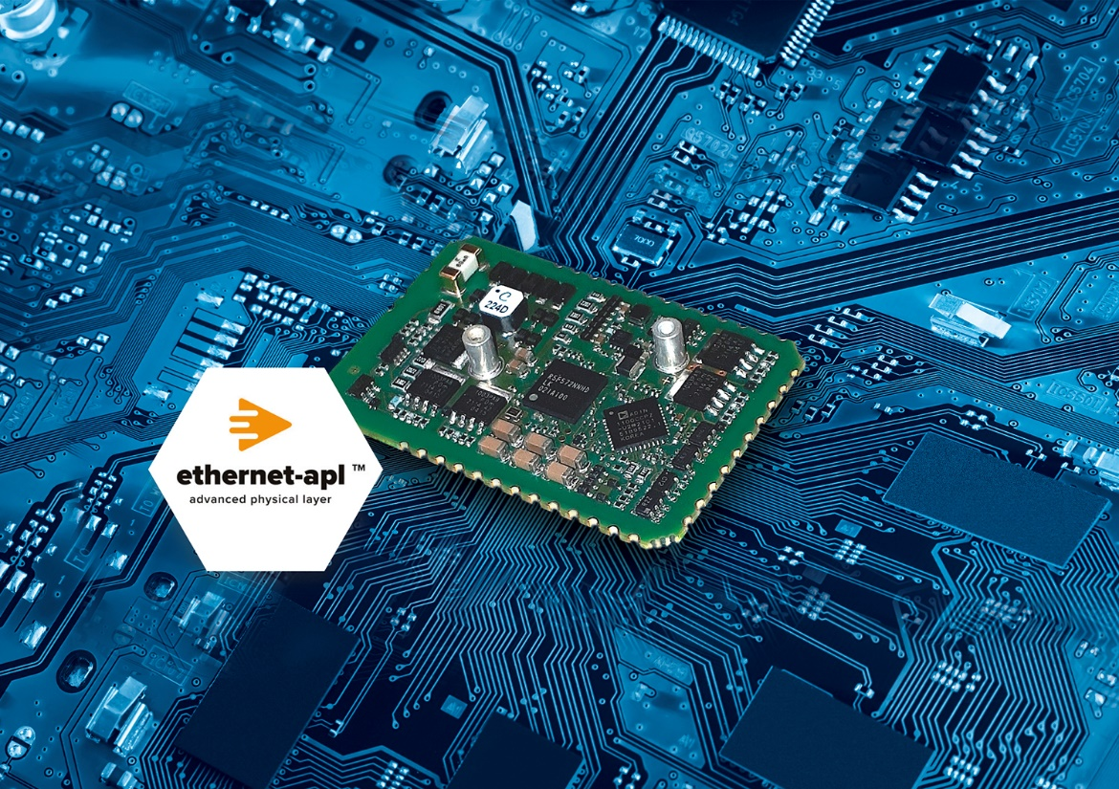Caption: Fast and reliable implementation of Ethernet-APL field devices (Source: Softing Industrial)
About Softing Industrial
Softing connects disparate automation components to feed data from the shop floor to the cloud for control and analytics. The company's products enable communications networks to be monitored and diagnosed to ensure a reliable flow of data, thereby creating the basis for optimizing production processes. For more information, please visit https://industrial.softing.com

Press Contact:
Stephanie Widder
Marketing Communications Specialist
Softing Industrial Automation GmbH
Richard-Reitzner-Allee 6
85540 Haar
Phone: +49-(0)89-45656-365
Email: stephanie.widder@softing.com

