Press Release
Softing Industrial

Softing Introduces Software Module for Connecting Modbus TCP Controllers to IIoT Applications
Haar, July 1st, 2021 – Softing adds to its Docker technology-based edgeConnector product family. The new edgeConnector Modbus is a flexible Docker container application for Modbus TCP controllers.
After edgeConnector Siemens for connecting SIMATIC S7 controllers and edgeConnector 840D for accessing data from SINUMERIK 840D controllers, Softing introduces edgeConnector Modbus. This Docker Container is suitable for connecting Modbus TCP controllers e.g., from Schneider Electric, Wago, Beckhoff or Phoenix Contact, to industrial IoT applications. edgeConnector Modbus can also be used to collect energy data or other process variables from Modbus-compatible sensors. An integrated OPC UA server enables simple and secure data connection to higher-level management systems, such as ERP, MES or process visualization systems. As a further communication protocol, MQTT makes it possible to integrate control data directly into private or public IoT cloud applications.
"By using container technology, our edgeConnector products are very quickly started up and running. They are operated on standard hardware and can be managed easily from a central platform. In this way, we offer our customers a simple and secure option for integrating data from production into innovative and flexible Industrial IoT solutions," says Sebastian Schenk, Product Manager at Softing Industrial.
All edgeConnector products support state-of-the-art security standards such as SSL/TLS, X.509 certificates, authentication, and data encryption. They are easy to configure locally via an integrated web interface or can be managed remotely via a REST API. For the future, Softing plans to further expand the edgeConnector product family to enable Ethernet/IP connectivity for Rockwell and Omron controllers. There are also plans to expand the configuration options from the cloud.
edgeConnector Modbus can be downloaded from online directories such as Docker Hub or Microsoft Azure Marketplace and tested for free. More information is available on the product website.
##
No. of characters / words: 2,130 / 300
Image:
Download 300 dpi
Download 72 dpi
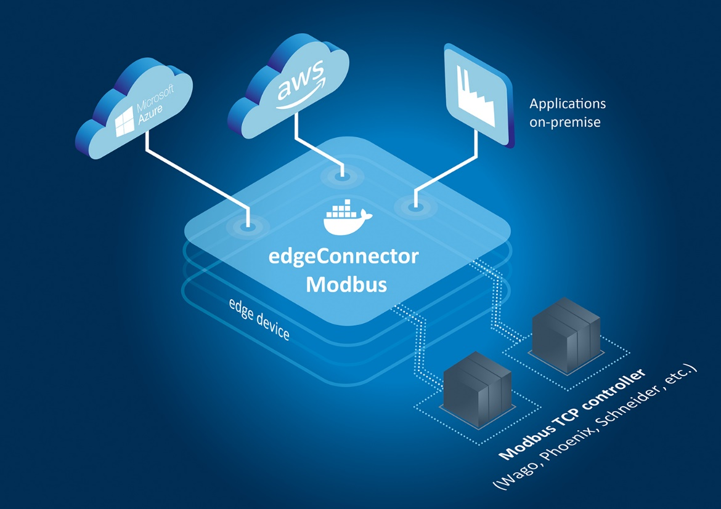
Caption: edgeConnector Modbus supports innovative industrial edge solutions. (Source: Softing Industrial)
About Softing Industrial
Softing connects disparate automation components to feed data from the shop floor to the cloud for control and analytics. The company's products enable communications networks to be monitored and diagnosed to ensure a reliable flow of data, thereby creating the basis for optimizing production processes. For more information, please visit https://industrial.softing.com

Press Contact:
Stephanie Widder
Marketing Communications Specialist
Softing Industrial Automation GmbH
Richard-Reitzner-Allee 6
85540 Haar
Phone: +49-(0)89-45656-365
Email: stephanie.widder@softing.com

