Press Release
Softing Industrial

Softing Industrial Automation contributes its edgePlug product family to the Siemens Industrial Edge Ecosystem
Haar, December 08, 2021 – Softing Industrial Automation GmbH will offer initial products on the Siemens Industrial Edge Marketplace in the first quarter of 2022.
Softing plans to launch its new edgePlug product family for the Siemens Industrial Edge Ecosystem in the first quarter of 2022. The company is thus one of the first 3rd party product providers on the Siemens Industrial Edge Marketplace. Industrial Edge is an open software platform that makes IT and software for the shopfloor simple, scalable, and manageable. The Marketplace acts as an entry point for software-related offerings from various vendors, making it easy for users to find and purchase all the products they need for Industrial Edge.
"I am very pleased that we were able to win Softing, which is one of the leading connectivity providers, as a partner for the Siemens Industrial Edge Ecosystem," says Jan Moehring, Industrial Edge Ecosystem Manager at Siemens.
In the first quarter of 2022, Softing will launch the three software products edgePlug SINUMERIK CNC, edgePlug FANUC CNC and edgePlug SIMATIC PLC. edgePlug SINUMERIK CNC provides access to data from Siemens 840D CNC controllers. The software supports access to Solution Line controllers as well as to older Power Line controllers. On the one hand, it provides machine data such as operating data, alarms, and energy data. On the other hand, it provides production data such as the drive current, the position values of the axes and information about the tools used and those located in the magazines.
With the second product - edgePlug FANUC CNC - machine and manufacturing data can be read from the FANUC CNC product series 30i-B, 31i-B, 32i-B, 35i-B and 0i-F.
The third product - edgePlug SIMATIC PLC - allows access to Siemens SIMATIC S7 controllers. The software supports access to data from the older S7-300 and S7-400 PLCs as well as the newer S7-1200 and S7-1500 PLCs. Users can continue working with optimized data blocks on the S7-1200 and S7-1500 PLCs because edgePlug SIMATIC PLC can read the variables of these data blocks.
All edgePlug products are seamlessly integrated into the Siemens Industrial Edge Device environment and can be configured via the integrated configuration tool.
##
No. of characters / words: approx. 2,340 / 370
Image:
Download 300 dpi
Download 72 dpi
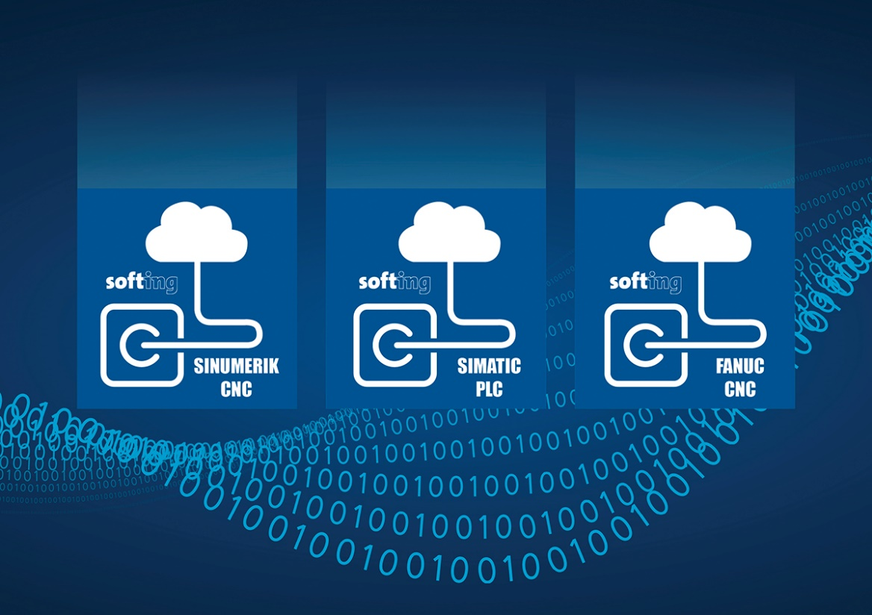Caption: Softing's edgePlug products are seamlessly integrated into the Siemens Industrial Edge Device environment (Source: Softing Industrial)
About Softing Industrial
Softing connects disparate automation components to feed data from the shop floor to the cloud for control and analytics. The company's products enable communications networks to be monitored and diagnosed to ensure a reliable flow of data, thereby creating the basis for optimizing production processes. For more information, please visit https://industrial.softing.com
Press Contact:
Stephanie Widder
Marketing Communications Specialist
Softing Industrial Automation GmbH
Richard-Reitzner-Allee 6
85540 Haar
Phone: +49-(0)89-45656-365
Email: stephanie.widder@softing.com

