Press Release
Softing Industrial

Softing expands IIoT gateway for Industry 4.0 integration in process plants
Haar, June 24, 2021 - smartLink HW-DP from Softing Industrial Automation provides controller-independent access to PROFIBUS DP networks. Besides HART IP and FDT, data for optimizing processes can now also be made available via an OPC UA interface. In addition, the new smartLink DTM enables FDT/DTM parameter setting for HART devices.
The smartLink HW-DP allows access to process data from PROFIBUS devices and HART devices connected to PROFIBUS remote I/Os, as well as secure export to any system inside or outside its own network. Users in the process industry who want to adapt their communication architecture to modern IIoT use cases can integrate smartLink into existing plants in a simple and cost-effective manner. Until now, access to data relevant for optimization processes was possible via HART IP for HART devices and FDT for PROFIBUS DP. The new version V 1.10 additionally provides an OPC UA interface. This means that any HART IP and OPC UA clients, such as Emerson's AMS Device Manager or the Android app DevComDroid, can now be used to configure, monitor, and evaluate field devices via these open communication standards. With the new smartLink DTM, FDT/DTM parameters can now also be set for HART devices.
Further information is available on the Softing website.
##
No. of characters / words: 1,360 / 220
Image:
Download 300 dpi
Download 72 dpi
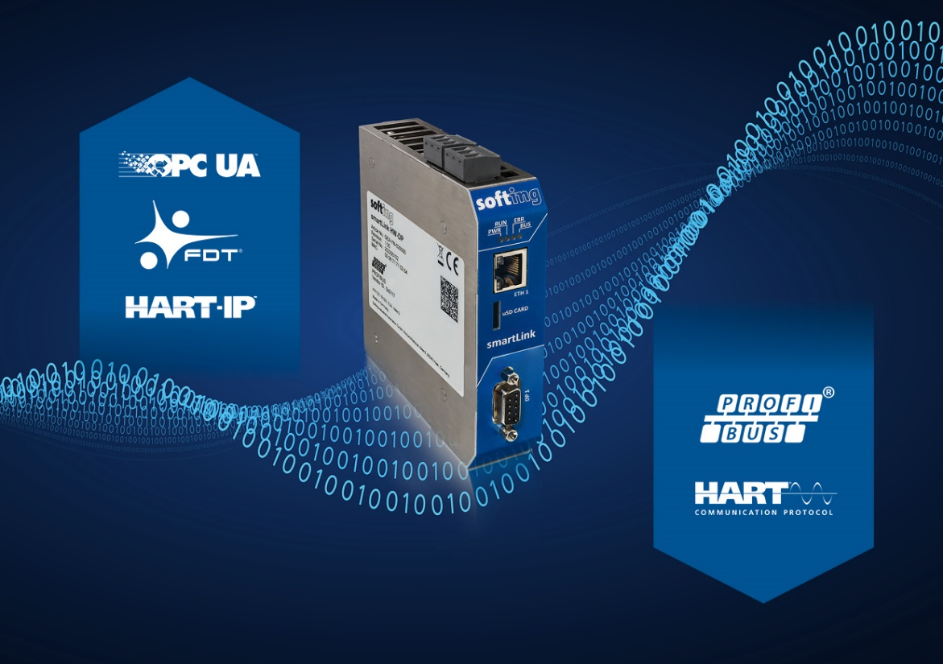
Caption: smartLink enables easy integration of Industry 4.0 applications into PROFIBUS & HART systems
Source: Softing
About Softing Industrial
Softing connects disparate automation components to feed data from the shop floor to the cloud for control and analytics. The company's products enable communication networks to be monitored and diagnosed to ensure a reliable flow of data, thereby creating the basis for optimizing production processes. For more information, please visit https://industrial.softing.com/
Press Contact:
Stephanie Widder
Marketing Communications Specialist
Softing Industrial Automation GmbH
Richard-Reitzner-Allee 6
85540 Haar
Phone: +49-(0)89-45656-365
Email: stephanie.widder@softing.com

