Press Release
Softing Industrial
Gateway for the integration of Industry 4.0 applications in PROFIBUS & HART systems
Haar, January 20, 2021 - smartLink HW-DP from Softing Industrial Automation provides controller-independent access to PROFIBUS DP networks. The compact tool can be integrated without affecting the operation of existing installations and thus enables Industry 4.0 connectivity for new and existing PROFIBUS DP networks.
The smartLink HW-DP V1.01 enables access to process, asset, and diagnostic data from PROFIBUS devices and HART devices connected to PROFIBUS remote I/Os. Furthermore, it allows for secure data export to any system inside and outside the company's own network. Users in the process industry who want to adapt their communication architecture to modern IoT use cases can integrate smartLink into existing plants in a simple and cost-effective manner. The data which is relevant for optimization processes is made available via open, standardized interfaces such as HART IP and FDT for subsequent applications This means that any HART IP clients, such as Emerson's AMS Device Manager or the Android app DevComDroid, can be used to set parameters for, monitor and evaluate field devices via these open communication standards.
Further information is available on the Softing website: https://industrial.softing.com/products/gateways/gateways-for-network-access-parallel-to-the-controller/smartlink-hw-dp.html
##

No. of characters / words: 1,280 / 190
Image:
Download 300 dpi
Download 72 dpi
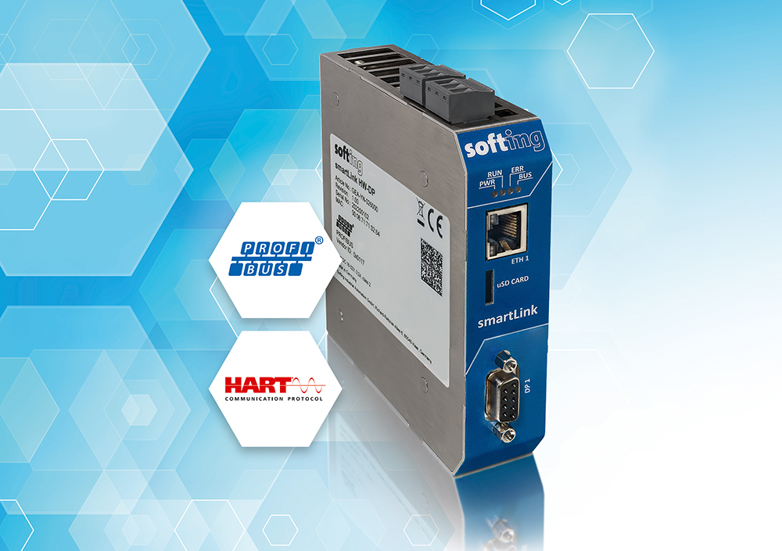
Caption: smartLink enables easy integration of Industry 4.0 applications into PROFIBUS & HART systems
About Softing Industrial
Softing connects disparate automation components to feed data from the shop floor to the cloud for control and analytics. The company's products enable communication networks to be monitored and diagnosed to ensure a reliable flow of data, thereby creating the basis for optimizing production processes. For more information, please visit https://industrial.softing.com/

Press Contact:
Stephanie Widder
Marketing Communications Specialist
Softing Industrial Automation GmbH
Richard-Reitzner-Allee 6
85540 Haar
Phone: +49-(0)89-45656-365
Email: stephanie.widder@softing.com

