Press Release
Softing Industrial
More flexibility for building IIoT solutions
Haar, October 28, 2021– The edgeConnector products from Softing's dataFEED family now support MQTT subscriber functionality and thus bidirectional communication with IoT cloud or IoT edge applications.
The new version 2.31 of Softing's edgeConnector products now supports MQTT subscriber functionality. The product family currently includes edgeConnector Siemens, edgeConnector 840D and edgeConnector Modbus. The software modules based on Docker technology provide state-of-the-art access to process data in SIMATIC S7, SINUMERIK 840D and Modbus TCP controllers. Using MQTT, the setup of IIoT solutions becomes even more flexible. For example, recipe management can be implemented from the cloud or in the edge by receiving data from an MQTT broker and writing it to a controller. Another use case is predictive maintenance via the MQTT protocol. This allows the application to actively intervene if, for example, the production process must be stopped to prevent potential machine failures. In addition, variables in the production process can be changed via the Monitor & Optimization (M&O) application as soon as M&O has identified the potential for improvement.
By using container technology, edgeConnector products are very quickly ready for use. They are operated on standard hardware and can be easily administered centrally. This gives users a simple and secure way to integrate data from production into innovative and flexible Industrial IoT solutions. All edgeConnector products support state-of-the-art security standards such as SSL/TLS, X.509 certificates, authentication, and data encryption. They can be easily configured locally via an integrated web interface or managed remotely via a REST API. The individual edgeConnector products are available for download and free trial from online directories such as Docker Hub or Microsoft Azure Marketplace. For more information, visit the Softing website.
##
No. of characters / words: approx. 1,960/280
Image:
Download 300 dpi
Download 72 dpi
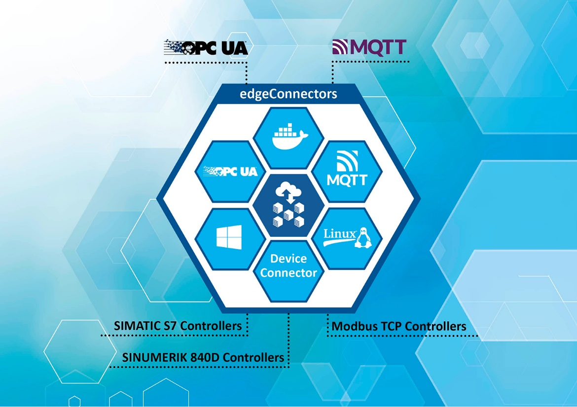Caption: More flexibility for building IIoT solutions with edgeConnector Products from Softing (Source: Softing Industrial)
About Softing Industrial
Softing connects disparate automation components to feed data from the shop floor to the cloud for control and analytics. The company's products enable communications networks to be monitored and diagnosed to ensure a reliable flow of data, thereby creating the basis for optimizing production processes. For more information, please visit https://industrial.softing.com

Press Contact:
Stephanie Widder
Marketing Communications Specialist
Softing Industrial Automation GmbH
Richard-Reitzner-Allee 6
85540 Haar
Phone: +49-(0)89-45656-365
Email: stephanie.widder@softing.com

