Press Release
Softing Industrial
Upgrading of HART and Modbus devices in process industry plants made easy
Haar, October 07, 2021– Softing’s commKit now supports Integrator Function Block and Standardized Connection Points for FOUNDATION Fieldbus plus several other new features which make retrofitting of HART and Modbus devices in process industry installations even easier.
commKit from Softing is a set which combines hardware, software, and customer specific consulting services for device manufacturers in the process industry who want to upgrade their existing HART or Modbus field devices for FOUNDATION Fieldbus or PROFIBUS PA in a fast and easy way. commKit consists of commModule MBP (Manchester Bus Powered), an interface hardware module for FF H1 or PROFIBUS PA, the software tool commScripter for generating the device-specific mapping function and a support service that accompanies the customer all the way to certification. The pre-certified hardware and pre-installed firmware reduce complex and expensive embedded software development to writing a simple parameter mapping table. This saves extensive programming effort and guarantees a fast time to market.
In the new version commKit V3.50, the commScripter Software for FF now supports Integrator Function Block and Standard Connection Points (SCP). SCP Support is especially important since it will be a mandatory feature for any device to be registered with FieldComm Group in the future. Furthermore, the FF demo device (CS START HART) has been registered with the FieldComm Group. This ensures that all functions and features available in customer-specific integrations also fully comply with the FF standard. As part of this process, a basic FDI package has also been registered.
For PROFIBUS PA, support for Totalizer Function Block was added. Now all Function Block types defined in the PA profile are available. Further new features are enhanced and unified diagnosis mapping for FF and PROFIBUS PA, and enhanced support for unmapped block parameters.
For the commModule MBP hardware, NVRAM (Non-Volatile Random Access Memory) verification was added. Verification results are indicated via the Diagnosis Transducer Block (DIAG-TB) provided by Softing, which offers advanced features for problem analysis and predictive maintenance.
Josef Luttenbacher, Product Manager at Softing Industrial says: “Industrie 4.0 and derived concepts such as the NAMUR Open Architecture (NOA) are focusing on the extensive data that digital field devices can supply for diagnostics and asset management. Consequently, we see a growing demand from device manufacturers to replace the analogue current loop interface and HART modem with a digital fieldbus interface for FOUNDATION Fieldbus or PROFIBUS PA. This usually requires extensive and costly development work for both software and hardware. For those, who do not have the capacity for a large-scale investment, our commKit offers an inexpensive retrofit and guarantees a fast time to market.”
##
No. of characters / words: approx. 2,970/440
Image:
Download 300 dpi
Download 72 dpi
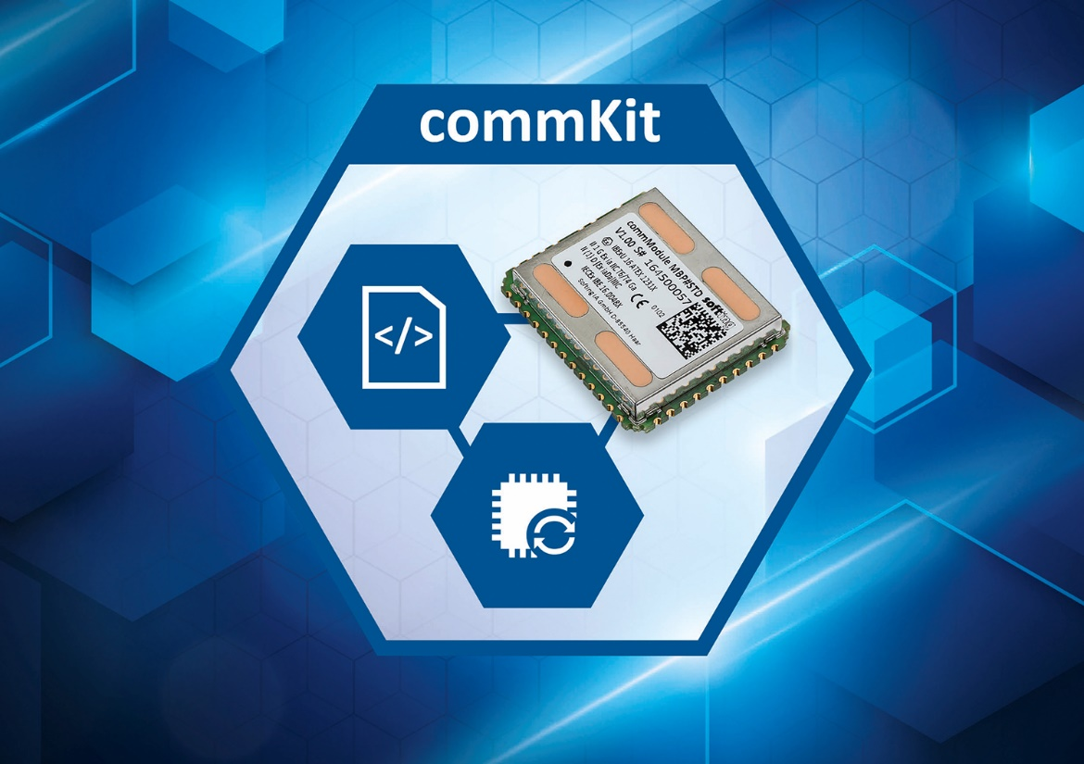 Caption: Easy retrofitting of HART and Modbus devices in process industry installations with commKit (Source: Softing Industrial)
About Softing Industrial
Softing connects disparate automation components to feed data from the shop floor to the cloud for control and analytics. The company's products enable communications networks to be monitored and diagnosed to ensure a reliable flow of data, thereby creating the basis for optimizing production processes. For more information, please visit https://industrial.softing.com

Press Contact:
Stephanie Widder
Marketing Communications Specialist
Softing Industrial Automation GmbH
Richard-Reitzner-Allee 6
85540 Haar
Phone: +49-(0)89-45656-365
Email: stephanie.widder@softing.com

