Press Release
Softing Industrial

Joint advancement in Ethernet APL – R. STAHL and Softing bundle their know-how
Haar, June 15, 2021 – Softing Industrial Automation GmbH becomes technology partner of R. STAHL Schaltgeraete GmbH for the further development and expansion of Ethernet-APL technology.
Ethernet-Advanced Physical Layer (Ethernet-APL) – the new 2-wire Ethernet for process automation – is the key technology for end-to-end digitalization of process plants down to the field level, including use in potentially hazardous areas. Since 2018, R. STAHL, the expert in safety technology for hazardous areas, has been cooperating with 11 leading manufacturers in the process industry as well as the four major organizations for process automation FieldComm Group, ODVA, OPC Foundation and PROFIBUS and PROFINET International (PI) in the "Ethernet-APL Project" to develop fundamentals and specifications for Ethernet to the field.
R. STAHL and Softing Industrial will soon present products and solutions in the form of Ethernet APL power switches and field switches, for installation in Zone 1 and 2 with intrinsically safe 2-WISE (2-Wire Intrinsically Safe Ethernet) field device connections for Zone 0. Softing contributes its intellectual property in the field of Industrial Ethernet switches and in the technologies of the participating organizations HART-IP, EtherNet/IP, OPC UA, and PROFINET to the partnership. Softing is a recognized specialist for industrial communication with fieldbuses and Industrial Ethernet protocols, for standardized data exchange, and the integration and configuration of devices and networks. According to André Fritsch, Senior Product Manager Remote I/O & Fieldbus at R. Stahl, "The technology partnership with Softing will advance the development of Ethernet APL solutions in the area of safety for hazardous areas as well as communication technology." Thomas Rummel, Senior Vice President Engineering & Product Management at Softing says, "We have known R. Stahl for a long time as an experienced and reliable business partner. Softing's expertise in Industrial Ethernet Switches together with R. Stahl's expertise in safety technology for hazardous areas guarantee that these two important requirements for Ethernet APL are perfectly met."
##

No. of characters / words: 2,245 / 320
Image:
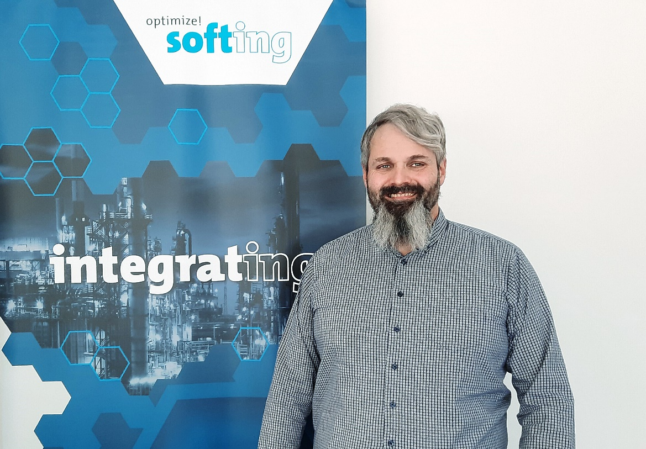
Caption: Thomas Rummel, Senior Vice President Engineering & Product Management Softing Industrial Automation GmbH: “Softing's expertise in Industrial Ethernet Switches together with R. Stahl's expertise in safety technology for hazardous areas guarantee that these two important requirements for Ethernet APL are perfectly met."
Source: Softing
Download 300 dpi
Download 72 dpi

About Softing Industrial
Softing connects disparate automation components to feed data from the shop floor to the cloud for control and analytics. The company's products enable communications networks to be monitored and diagnosed to ensure a reliable flow of data, thereby creating the basis for optimizing production processes. For more information, please visit https://industrial.softing.com

Press Contact:
Stephanie Widder
Marketing Communications Specialist
Softing Industrial Automation GmbH
Richard-Reitzner-Allee 6
85540 Haar
Phone: +49-(0)89-45656-365
Email: stephanie.widder@softing.com

