Press Release
Softing Industrial
Softing provides Pub/Sub Implementation for OPC UA .NET Standard Stack
Haar, February 25, 2021 – Softing Industrial announces the contribution of its publisher/subscriber (pub/sub) implementation to the OPC UA .NET Standard Stack, thereby improving the performance, reliability, and scalability of this open-source project.
By contributing its pub/sub implementation to the OPC UA .NET Standard Stack, Softing continues its long-term commitment to the OPC UA standard and the open-source initiative of the OPC Foundation. The pub/sub implementation is based on the User Datagram Protocol (UDP). It enables integration of OPC UA at the shop-floor level where UDP helps to establish the required low-power, low-latency, loss tolerating communication on LANs. Pub/sub also simplifies integration of OPC UA in scalable cloud-based applications where it enables deterministic machine control as well as bidirectional communication between the cloud and shop floor.
The OPC Foundation .NET Standard Stack, based on the .NET Standard Library technology, was developed, and optimized by Microsoft and made available on GitHub in 2016. This was followed by Softing offering a commercial license for the stack, which made it available for full commercial use by everyone.
“We are proud to participate in the ongoing development of the OPC UA .NET Standard Stack. Our pub/sub implementation was originally part of our dataFEED OPC UA .NET Standard Software Development Kit (SDK), which is relied upon by numerous customers in the industry. By contributing to the open-source project, we are taking another step towards facilitating the implementation of IIoT and Industry 4.0 applications, says Sebastian Fischer, Product Manager at Softing Industrial Automation. We plan to provide further enhancements, with MQTT being our next project.”
Information about OPC UA .NET Standard Stack can be found on the OPC Foundation Website: opcfoundation.org
##
No. of characters / words: approx. 2,060/305
Image:
Download 300 dpi
Download 72 dpi
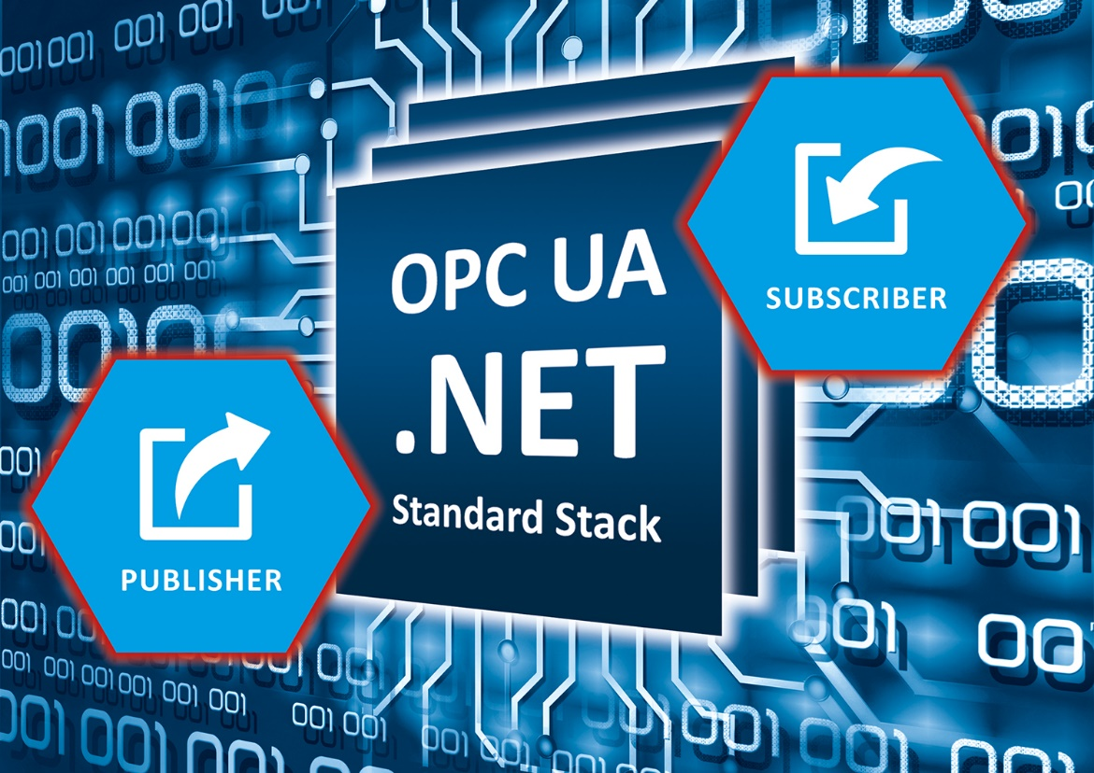
Caption: Pub/sub implementation for OPC UA .NET standard stack improves performance, reliability and scalability of this open source project
About Softing Industrial
Softing connects disparate automation components to feed data from the shop floor to the cloud for control and analytics. The company's products enable communications networks to be monitored and diagnosed to ensure a reliable flow of data, thereby creating the basis for optimizing production processes. For more information, please visit https://industrial.softing.com

Press Contact:
Stephanie Widder
Marketing Communications Specialist
Softing Industrial Automation GmbH
Richard-Reitzner-Allee 6
85540 Haar
Phone: +49-(0)89-45656-365
Email: stephanie.widder@softing.com

