Press Release
Softing Industrial
New AWS Quick Start for Softing edgeConnector Siemens Available
Haar, April 13, 2021 – Softing Industrial launches an AWS Quick Start for its edgeConnector Siemens docker container application, in collaboration with Amazon Web Services (AWS). The Quick Start automatically deploys edgeConnector Siemens and AWS IoT SiteWise in the AWS cloud. It demonstrates how to connect Siemens PLCs to the AWS cloud in a secure and scalable way.

Customers are increasingly facing challenges in connecting the cloud to the edge in a secure way. “Many customers that we speak to, are hesitant when it comes to connecting their machines to cloud and using the Internet of Things” says Dr. Christopher Anhalt, VP Product Marketing at Softing Industrial Automation GmbH. Industrial customers lack experience in edge computing and do not have access to reference artifacts and best-practices resources for edge computing and the Internet of Things.
The Softing edgeConnector Siemens Quick Start makes it easy for IT as well as for shopfloor personnel to gain first-hand experience with a secure and highly scalable end-to-end solution for Industrial IoT. The Quick Start offers a fast and flexible way to try out edgeConnector Siemens as connectivity solution with AWS. It automates the deployment of Softing’s edgeConnector Siemens, a docker container application with gateway functionality, and AWS IoT SiteWise in the AWS cloud. A simulated Siemens S7-1500 PLC generates IoT sensor data that is sent to AWS via edgeConnector Siemens and visualized using AWS IoT SiteWise. This entire deployment on AWS takes not more than 10 minutes.
edgeConnector Siemens is Softing’s first commercially available gateway product to support container technology. By leveraging Softing’s expertise in automation technology and IT/OT integration, it offers best-in-class connectivity for Siemens PLCs typically used in brownfield projects. As a Docker container, it seamlessly integrates into the AWS solution architecture for Industrial IoT and can be operated and managed efficiently. The AWS Quick Start for edgeConnector Siemens and AWS IoT SiteWise is available at: https://aws.amazon.com/quickstart/architecture/softing-edgeconnector-siemens/
More information is available here: https://industrial.softing.com/aws-quick-start.html
##
Word count: approximately 330
Number of characters: approximately 2,300

Image:
Download 300 dpi
Download 72 dpi
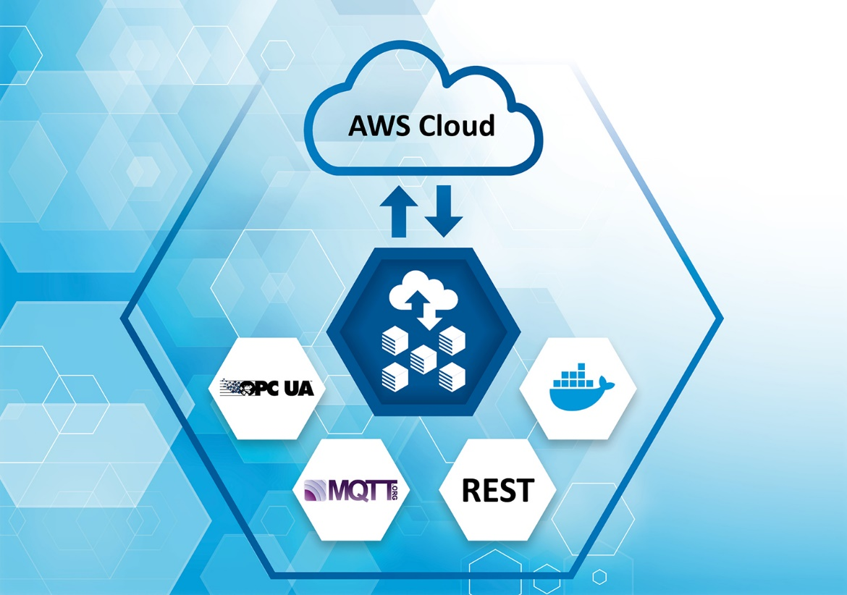
Caption: The Quick Start offers a fast and flexible way to try out edgeConnector Siemens as connectivity solution with AWS.

About Softing Industrial
Softing connects disparate automation components to feed data from the shop floor to the cloud for control and analytics. The company's products enable communications networks to be monitored and diagnosed to ensure a reliable flow of data, thereby creating the basis for optimizing production processes. For more information, please visit https://industrial.softing.com

Press Contact:
Stephanie Widder
Marketing Communications Specialist
Softing Industrial Automation GmbH
Richard-Reitzner-Allee 6
85540 Haar
Phone: +49-(0)89-45656-365
Email: stephanie.widder@softing.com

