Press Release
Softing Industrial
OPC UA Embedded Toolkit from Softing Now Includes Discovery Announcements
Haar, February 6, 2020 – Version 1.31 uaToolkit Embedded adds metadata and discovery announcements to OPC UA field devices which eliminates the need for preset information in the subscriber.
Softing's uaToolkit Embedded for implementing embedded OPC UA Servers with client/server and publisher/subscriber communication just enhanced the OPC UA publisher and subscriber with metadata and discovery announcements. The publisher now sends the metadata for the published data set. The subscriber can use this data for the decoding of the published data set which reduces the need of preset information in the subscriber. V1.31 also supports the latest Long-Term Support version (LTS) V1.1.1 of OpenSSL. (LTS for OpenSSL V1.0.2 ended on December 31, 2019 but is still supported).
“As industry 4.0 and IIoT continue to develop, we have seen a very significant and sustained increase in OPC UA adoption. The uaToolkit Embedded is our offering for customers who want to use OPC UA in sensors, small devices and low-end controllers,” says Thomas Rummel, Senior Vice President Engineering & Product Management at Softing Industrial. “Meanwhile there is an increasing amount of OPC UA Companion specifications for devices. The VDMA (Germany’s Mechanical Engineering Industry Association) alone coordinates the activities of over 26 working groups that define a common, cross-sectoral language between machines and plants. And the new OPC UA FLC (Field Level Communication) initiative will further increase the demand for embedded OPC UA.”
Softing's uaToolkit Embedded has been certified in the Compliance Lab of the OPC Foundation for the Nano Embedded Device Server profile, the Micro Embedded Device Server profile and the Embedded UA Server profile. The toolkit has a low memory footprint and requires little computing power. This makes it particularly suitable for firmware development of field devices, and also for use in control or remote I/O systems with limited resources. It also supports OPC UA Companion specifications with a tool for importing OPC UA nodesets.
The toolkit is available on the Softing Website as full and trial version: https://industrial.softing.com/en/products/protocol-software-and-sdks/opc-ua-embedded-toolkit.html
A source code for the evaluation of the toolkit is available on request.
##
Word count: 349
No. of characters: 2,376
Download: Press Image 300dpi
Download: Press Image 72dpi 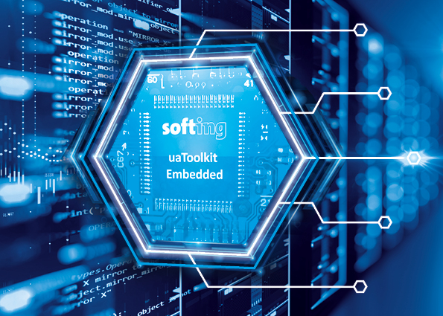
Caption: Softings uaToolkit Embedded adds metadata and discovery announcements
About Softing Industrial
Softing connects disparate automation components to feed data from the shop floor to the cloud for control and analytics. The company's products enable communication networks to be monitored and diagnosed to ensure a reliable flow of data, thereby creating the basis for optimizing production processes. For more information, please visit http://industrial.softing.com

Press Contact:
Stephanie Widder
Marketing Communications Specialist
Industrial – Data Networks
Softing Industrial Automation GmbH
Richard-Reitzner-Allee 6
85540 Haar
Phone: +49-(0)89-45656-365
Email: stephanie.widder@softing.com

