Press Release
Softing Industrial
Softing enhances edgeConnector Siemens
Haar/Germany, October 6, 2020 – Softing Industrial releases version v1.20 of edgeConnector Siemens. The software module is based on container technology and connects Siemens controllers with industrial IoT applications. In addition to SIMATIC S7-1200 and S7-1500, the new version also supports SIMATIC S7-300/400 controllers.
edgeConnector Siemens enables access to SIMATIC S7-1200 and S7-1500 data including optimized data blocks. Version v1.20 additionally supports SIMATIC S7-300/400 controllers. Client applications have access to data via the interoperability standard OPC UA. The product can be configured locally via a built-in web interface, or remotely via a REST interface. It seamlessly integrates with Azure IoT Edge and AWS IoT Greengrass and is made available via online repositories such as Docker Hub.
Users benefit from flexible deployment and ease of use which comes with virtualization and container technology. Valuable process and machine data are made available for innovative IoT applications without any changes to controller or automation network configuration. Advanced security features such as the management of access right for individual client applications increase the security of the entire solution.
“edgeConnector Siemens is the first strategic expansion of our dataFEED product family to include virtualization and container technology”, says Wolfgang Wende, Senior VP Sales at Softing Industrial. It leverages Softing's extensive experience with brownfield connectivity and OPC UA technology and makes it available for new and highly efficient IoT solution architectures.”
edgeConnector Siemens can be tested for free. It is currently evaluated by customers in the automotive, aerospace and food & beverage industry. Further information can be found on the product website.
##

No. of characters / words: approx. 1,850 / 260
Image:
Download 300 dpi
Download 72 dpi
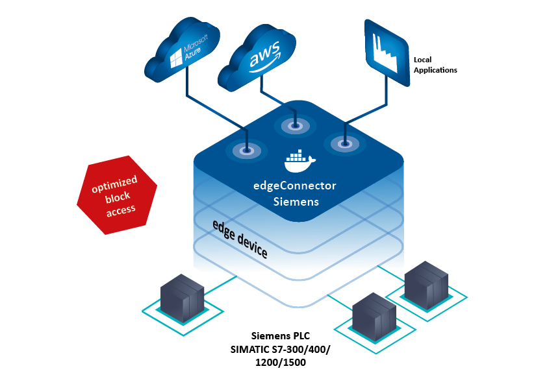
Caption: edgeConnector Siemens supports innovative industrial edge solutions.
About Softing Industrial
Softing connects disparate automation components to feed data from the shop floor to the cloud for control and analytics. The company's products enable communication networks to be monitored and diagnosed to ensure a reliable flow of data, thereby creating the basis for optimizing production processes. For more information, please visit http://industrial.softing.com

Press Contact:
Stephanie Widder
Marketing Communications Specialist
Softing Industrial Automation GmbH
Richard-Reitzner-Allee 6
85540 Haar
Phone: +49-(0)89-45656-365
Email: stephanie.widder@softing.com

