Press Release
Softing Industrial
Softing Releases Siemens Connector for Industrial Edge Applications
Haar/Germany, May 26, 2020 – Softing Industrial’s new “edgeConnector Siemens” is the company’s first connectivity product based on container technology. The product connects Siemens controllers with software applications. It supports the reference architectures for Industrial IoT by Microsoft Azure and Amazon AWS, as well as independent edge solutions.
edgeConnector Siemens enables access to SIMATIC S7-1200 and S7-1500 data including optimized data blocks. Client applications have access to data via the interoperability standard OPC UA. The product can be configured locally via a built-in web interface, or remotely via a REST interface. It seamlessly integrates with Azure IoT Edge and AWS IoT Greengrass and is made available via online repositories such as Docker Hub.
Users benefit from flexible deployment and ease of use which comes with virtualization and container technology. Valuable process and machine data are made available for innovative IoT applications without any changes to controller or automation network configuration. Advanced security features such as the management of access right for individual client applications increase the security of the entire solution.
“The release of edgeConnector Siemens represents a major evolution of our dataFEED product family”, says Wolfgang Wende, Senior VP Sales at Softing Industrial. “dataFEED is developing into a leading offering for industrial edge. The product family helps customers and system integrators to efficiently bridge the gap between OT and IT in industrial IoT”.
edgeConnector Siemens is now available for purchase and can be tested for free. It is currently evaluated by customers in the automotive, aerospace and food & beverage industry. Further information can be found on the product website.

##
Word count: 268
No. of characters: 1,853
Image:
Download 300 dpi
Download 72 dpi
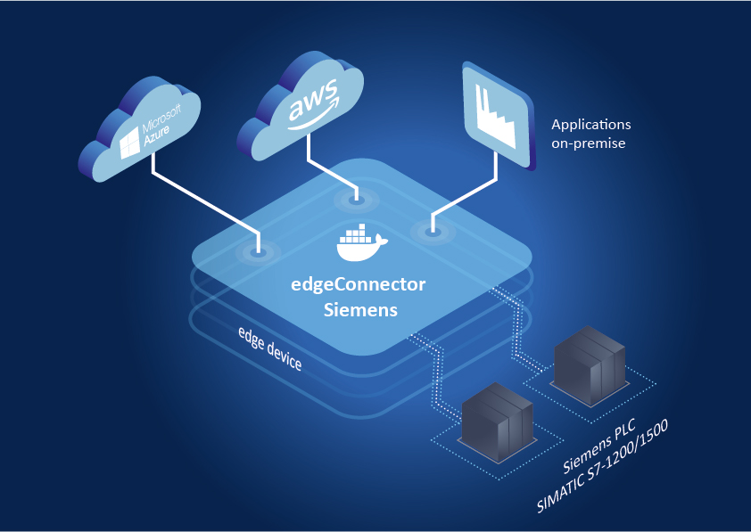
Caption: The edgeConnector Siemens supports innovative industrial edge solutions.
About Softing Industrial
Softing connects disparate automation components to feed data from the shop floor to the cloud for control and analytics. The company's products enable communication networks to be monitored and diagnosed to ensure a reliable flow of data, thereby creating the basis for optimizing production processes. For more information, please visit http://industrial.softing.com

Press Contact:
Stephanie Widder
Marketing Communications Specialist
Softing Industrial Automation GmbH
Richard-Reitzner-Allee 6
85540 Haar
Phone: +49-(0)89-45656-365
Email: stephanie.widder@softing.com

